FIX WI-FI CONNECTION ISSUES IN WINDOWS 11

Steps to follow.
1. Things to try first.
- Make sure Wi-Fi is turned on.
- Make sure Airplane mode is turned off.
- Does Wi-Fi network appear in the list of networks?
- If connected, disconnect and reconnect.
- Try connecting on a different frequency band (2.4GHz and 5GHz).
- Make sure physical Wi-Fi switch on your laptop is turned on.
- Run the network trouble-shooter.
- Restart your modem and wireless router.

2. Narrow down the source of the problem.
- If Wi-Fi is connected, try a different website.
- On another laptop or phone, try to connect to the same network.
- Check to see if there is a problem with the connection to your Wi-Fi router.
3. Network troubleshooting on your device.
- Run network commands.
- Uninstall the network adapter driver and restart.
- Check if your network adapter is compatible with the latest Windows update.
- Use network reset.

4. Additional troubleshooting steps.
- Check your Wi-Fi settings.
- Wireless mode settings.
- Wi-Fi profile settings.
- Forget a network.
- Check your home layout.

Wireless technologies
1. Frequency bands
2.4 Ghz
Benefits: Longer Distance range/ Signal strength, better in going through obstacles (penetrate through walls), More devices support this frequency, IOT Devices. Channel 1-6-11 do not overlap in this frequency.
Drawbacks: Smaller Bandwidth, Channels overlap (more congestion) as most devices in the household uses 2.4GHz. Support channels from 1-11 channels can overlap.

5 Ghz
Benefits: Bigger Bandwidth (Faster throughput), less congested channels, only latest devices support them.
Drawbacks: Shorter Distance range indoor, doesn't go through walls and other obstacles.
2. SSID's
WAP names-32 characters
uniquely name SSIDs for 2.4Ghz & 5Ghz
Hide SSID for security but not recommended
3. Choosing the right channel
use WiFi Analyser app
2.4Ghz 1-6-11 channels do not overlap
5 Ghz not many channels overlap.
4. Check the Channel Width
20 Mhz- 2.4/5 Ghz
40Mhz- 2.4/5 Ghz
80 Mhz -5 Ghz
160 Mhz -5 Ghz
5. IEEE Standards 802.11x – wireless networks
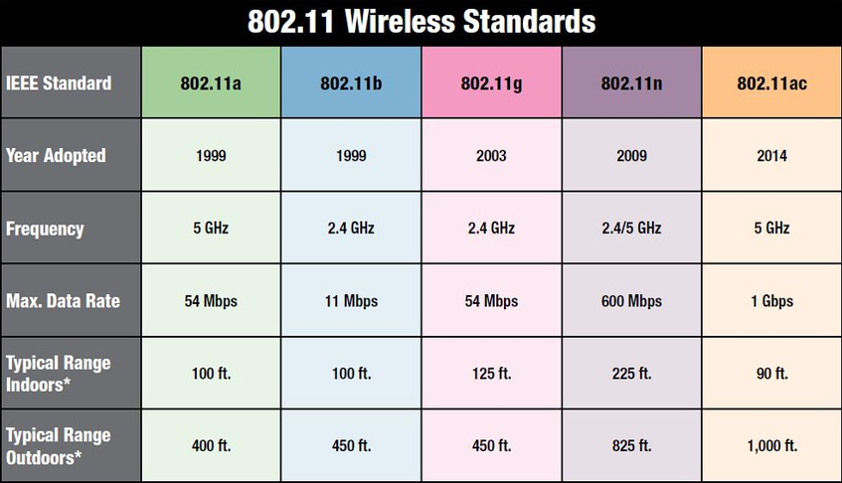

6. Wireless Security Modes
WPS - Wireless pairing mode, not very secure, turned off.
WEP- Weakest Security, 1 password- plain text, Brute force attack using IV force, RC4 cipher.
WPA- TKIP worked against IV attack.
WPAv2- AES replaced RC4 cipher uses block chain cipher CCMP.
Personal- 1 password to authenticate.
Enterprise- Login with username and password
Authentication server
Radius server
Security policy 802.1x (EAP)
WPAv3- Personal- 1 password to authenticate
Enterprise- Login with username and password
Authentication server
Radius server
Security policy 802.1x (EAP)

7. Positioning the wireless router
Place your wireless router in a central location.
Position the wireless router off the floor and away from walls and metal objects.
Reduce interference EMI.

8. Wireless Network Analysing commands
- netsh wlan show wlanreport
This will generate a wireless network report that’s saved as an HTML file. The report shows all the Wi-Fi events from the last three days and groups them by Wi-Fi connection sessions. It also shows the results of several network-related command line scripts and a list of all the network adapters on your PC.
- Ipconfig /all.
Shows detailed information about the state of the adapters on the system. This includes the physical (MAC) address, IP address, DNS server, if DHCP is enabled, and much more.
- NetSh WLAN Show All
Shows detailed information about your Wi-Fi adapter including the adapter’s capabilities, the Wi-Fi profiles on your PC (not including security keys or passwords), and a list of the Wi-Fi networks that were found when you ran the report.
- CertUtil -store -silent My & certutil -store -silent -user My
Contains a list of the current certificates on your PC.

9. Tools and Apps
- create the wireless network report- netsh wlan show wlanreport
- A Wi-Fi analyzer app
- A network speed test app
- Wireless router software GUI

10.Wireless Security measures

- Change the router default username and password to secure your device.
- Set up a new security key (password) for your network.
- Write down your security key and keep it in a safe place.
- Use a firewall.
- Change your SSID to an appropriate name.
- Disable the Guest network if enabled or only use when needed.
- Manage your Access point power to control the range of the router.
- Use VPN & HTTPs on Open or Public networks for security.

